**Module 15 Challenge - Leaflet**

**SMU DS – Raj Agrawal**

**Submitted on: 09-AUG-2023**

**Repository – https://github.com/RajAgrawal99/SMU_DS_Bootcamp_March2023_RA.git**

**Folder – leaflet-challenge**

**Data source**

<https://earthquake.usgs.gov/earthquakes/feed/v1.0/geojson.php>

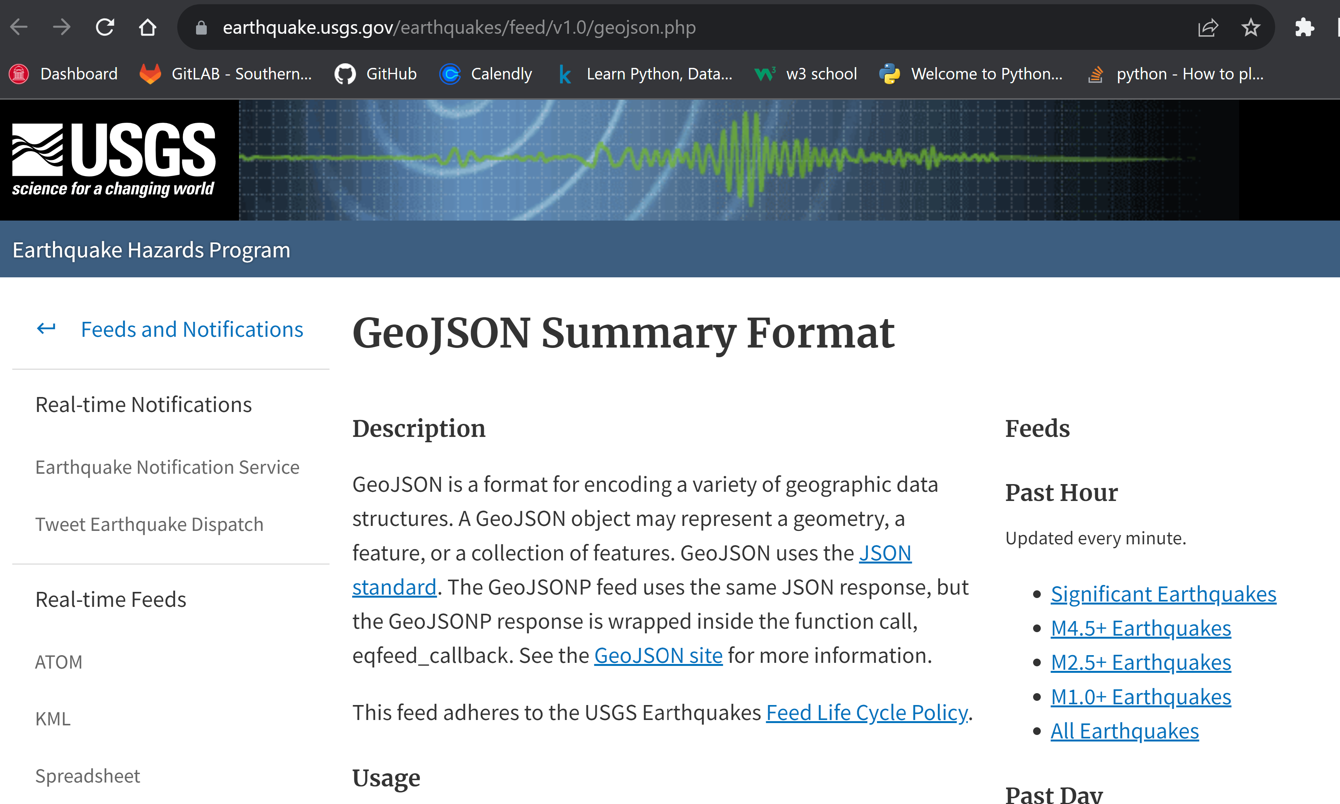

**Sample index.html**

<!DOCTYPE html>

<html lang="en">

<head>

  <meta charset="UTF-8">

  <meta name="viewport" content="width=device-width, initial-scale=1.0">

  <meta http-equiv="X-UA-Compatible" content="ie=edge">

  <title>Leaflet Step-1</title>

**Sample logic.js**

// SMU DS leaflet-challenge Part 1: Create the Earthquake Visualization

function clickListener() {

  let filter = document.getElementById('earthquake_filter').value;

  // STEP 0: GET THE DATA

  // Store our API endpoint as queryUrl.

  let queryUrl = `https://earthquake.usgs.gov/earthquakes/feed/v1.0/summary/all_${filter}.geojson`;

  let url2 = "https://raw.githubusercontent.com/fraxen/tectonicplates/master/GeoJSON/PB2002_boundaries.json";

**Part 1: Create the Earthquake Visualization**

1. Imported and visualize the data by doing the following:
   * Using Leaflet, created a map that plots all the earthquakes from your dataset based on their longitude and latitude.
     + data markers reflect the magnitude of the earthquake by their size and the depth of the earthquake by color. Earthquakes with higher magnitudes should appear larger, and earthquakes with greater depth should appear darker in color.
   * Included popups that provide additional information about the earthquake when its associated marker is clicked.
   * Created a legend that will provide context for your map data.



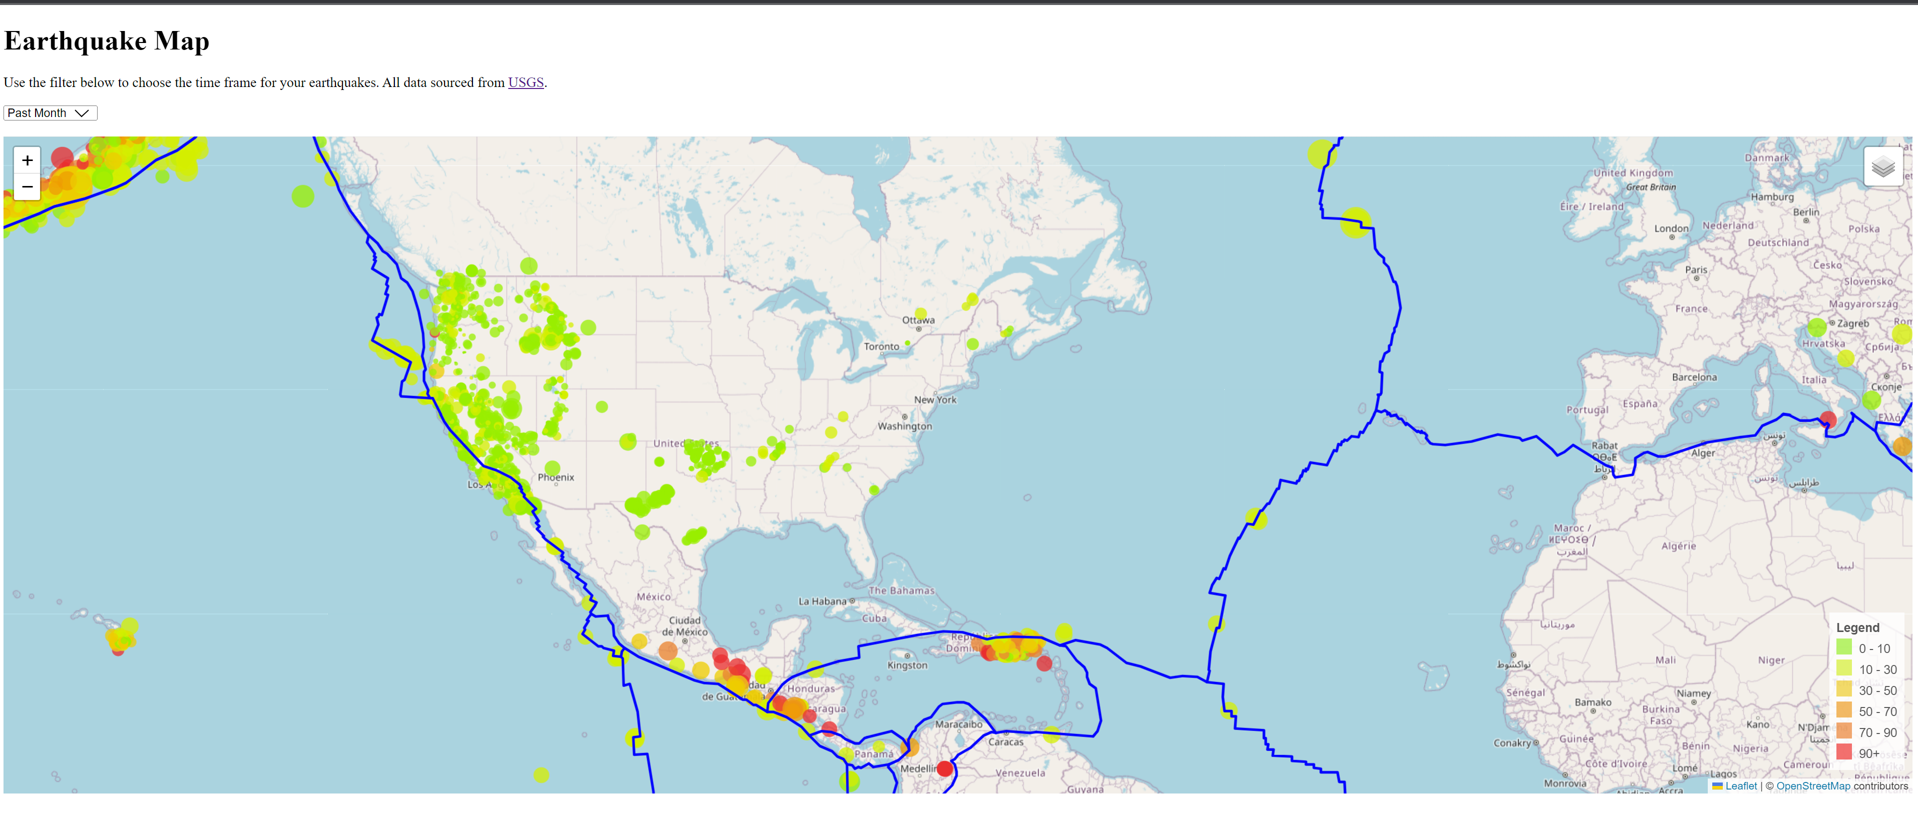

README.md file added to the folder